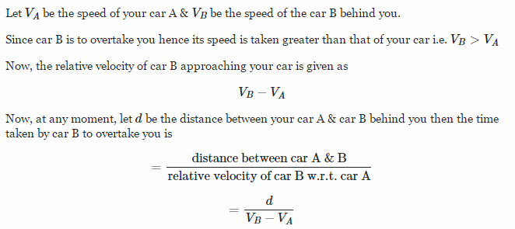
Kinematics involving an object overtaking another. Both objects have a constant velocity but one is large than the other. The objects start at different positions for this to be true.

